Relational Databases with MySQL Week 5 Coding Assignment

|  |  |  |
| --- | --- | --- |
| Category | Criteria | % of Grade |
| Functionality | Does the code work? | 25 |
| Organization | Is the code clean and organized? Proper use of white space, syntax, and consistency are utilized. Names and comments are concise and clear. | 25 |
| Creativity | Student solved the problems presented in the assignment using creativity and out of the box thinking. | 25 |
| Completeness | All requirements of the assignment are complete. | 25 |

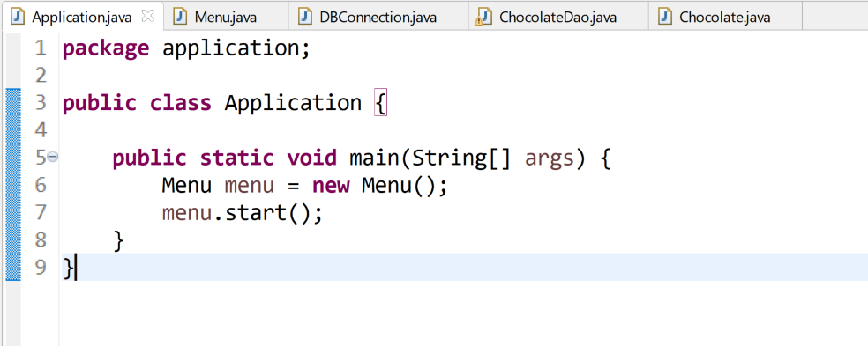**Screenshots of Code:**

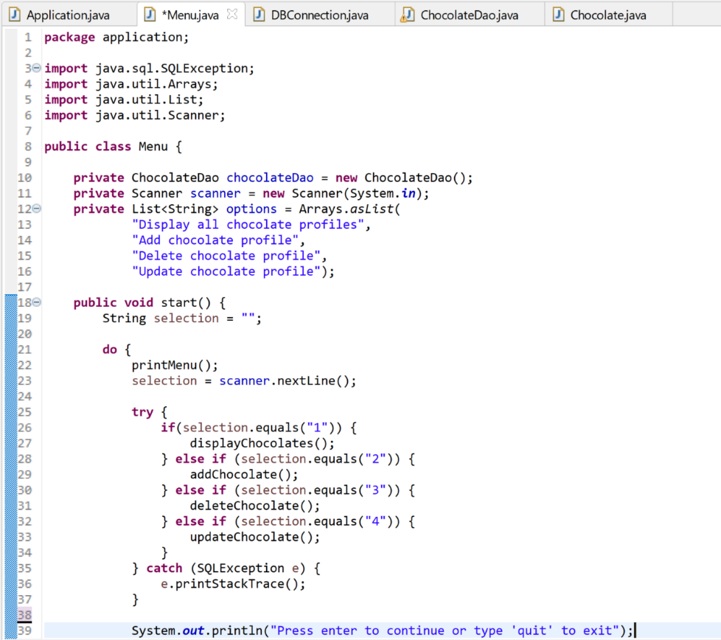

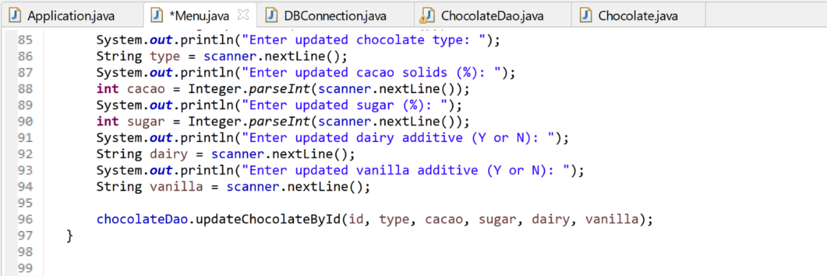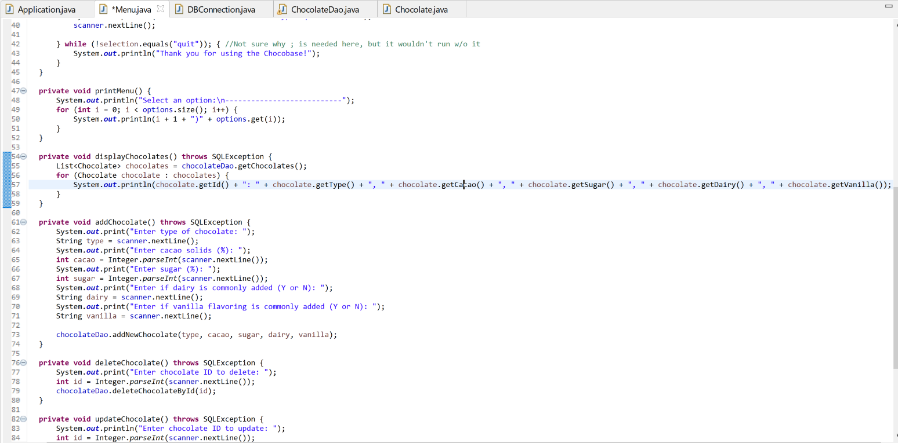

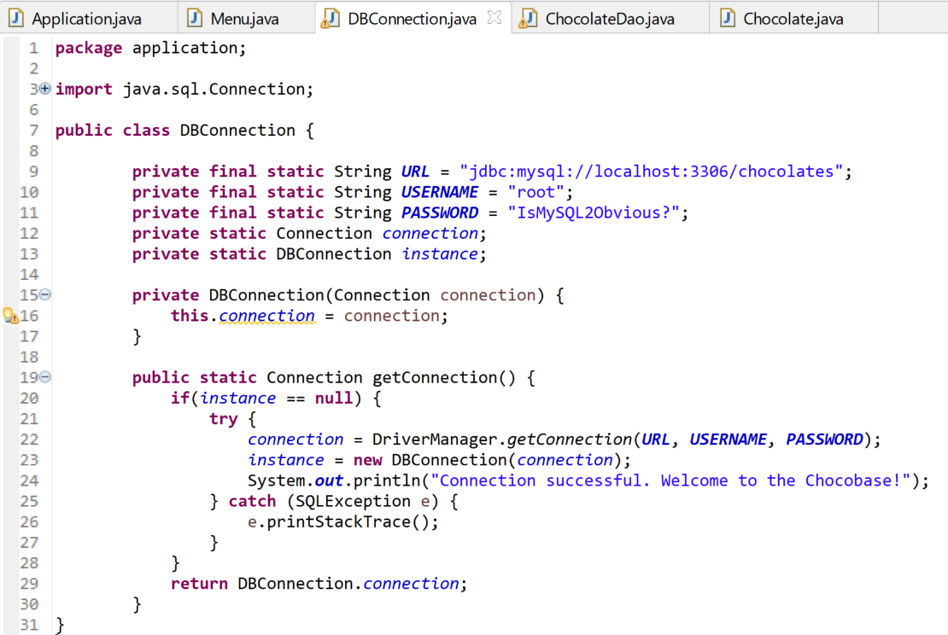

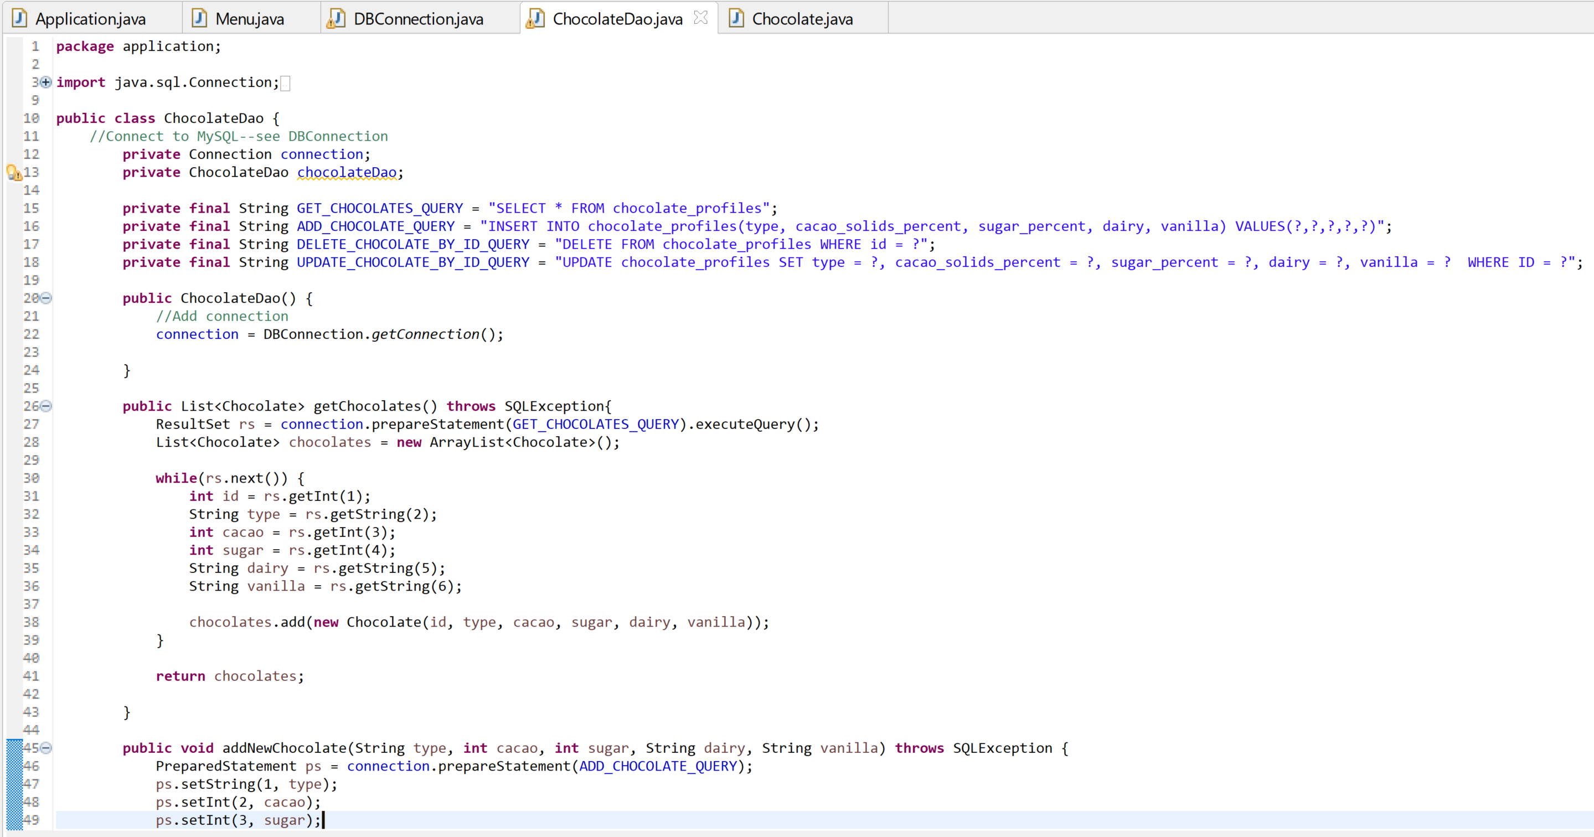

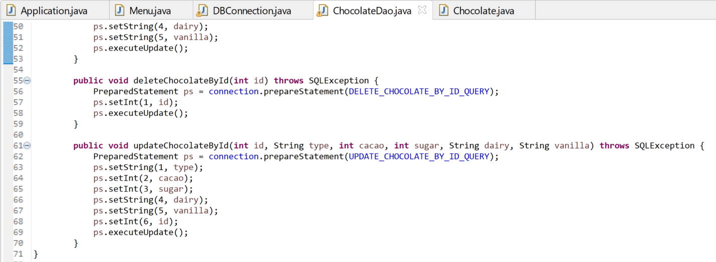

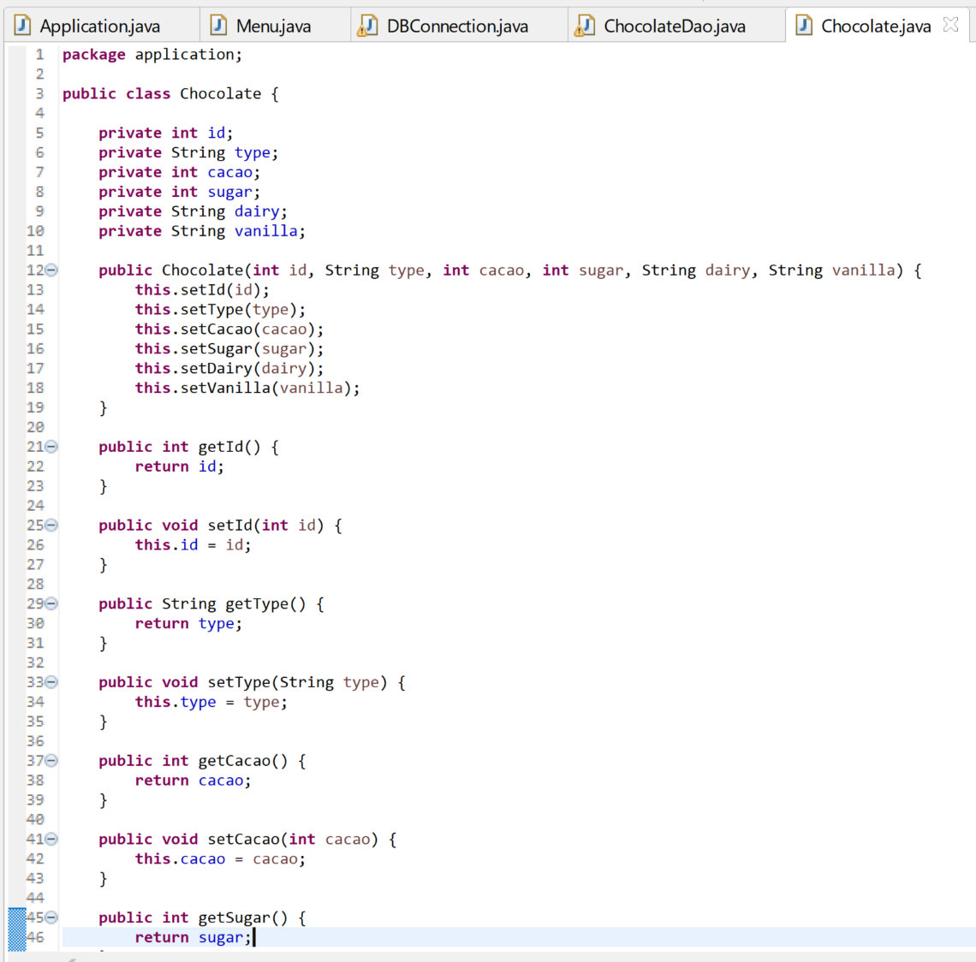

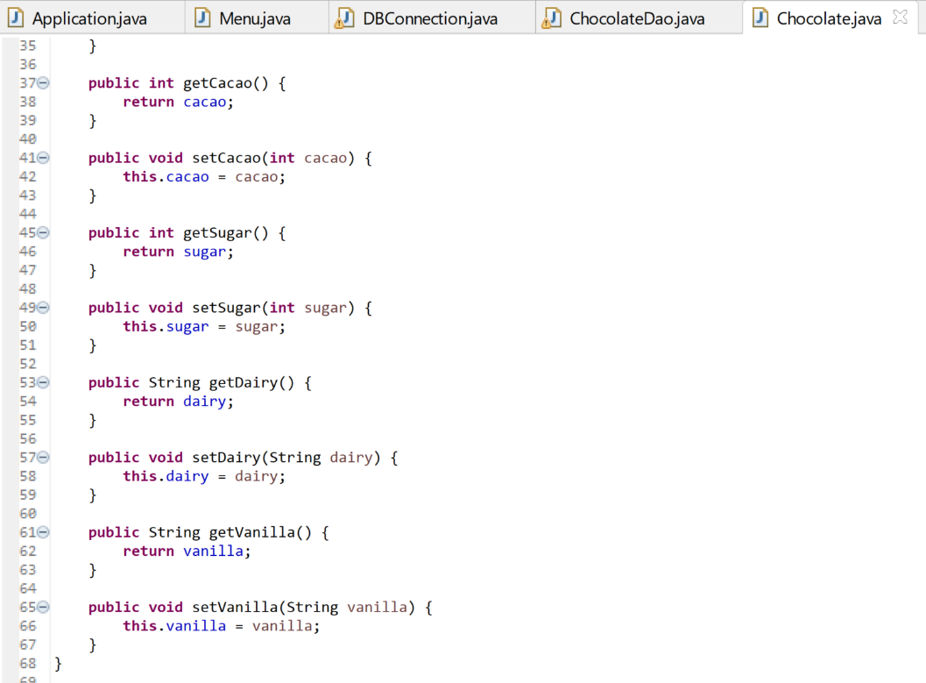

**Screenshots of Running Application:**

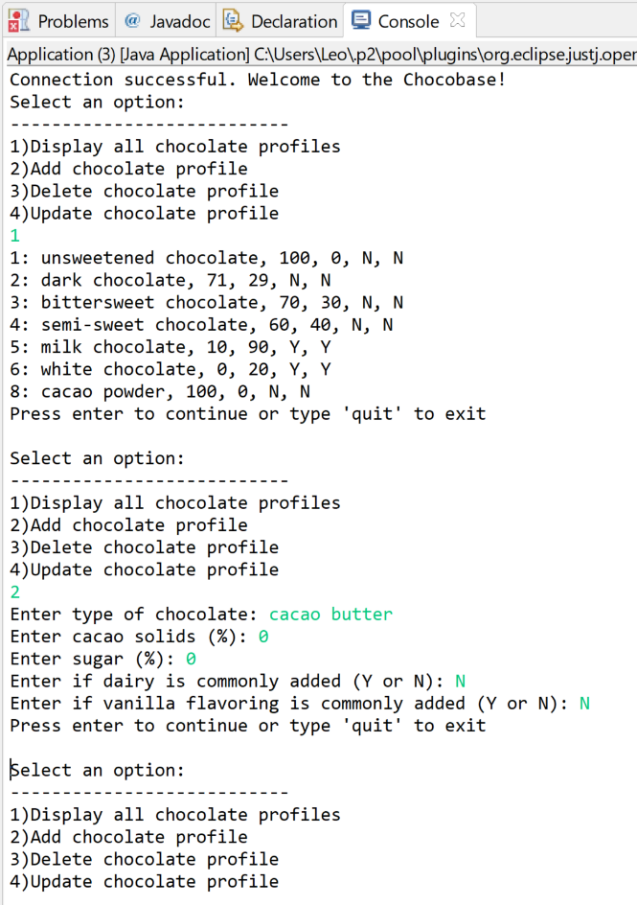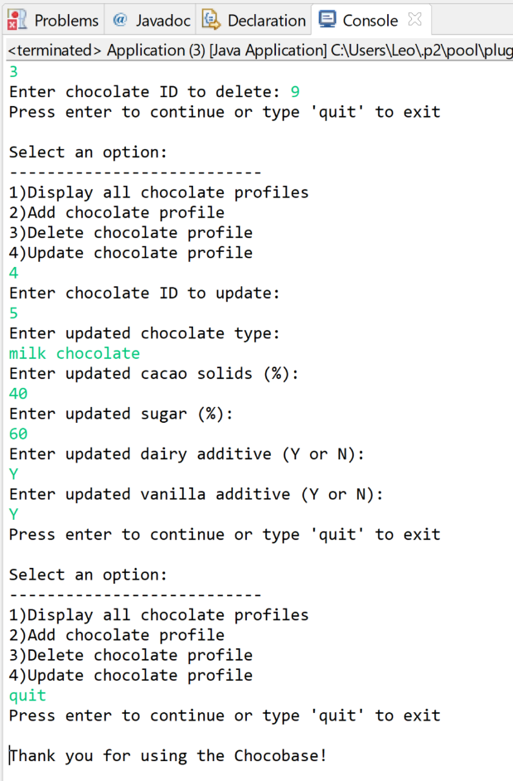

**URL to GitHub Repository:** https://github.com/radubuc/mysql-week-5